V Teplicích 31. 8. 2026

MATURITNÍ ZKOUŠKA 2027
Anglický jazyk – odborná část

Topics for the field of study - Means of Transport

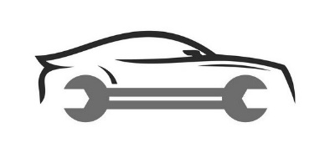
- Means of transport
- Car parts
- Pre-drive check
- Tyres - dimensions
- Tyres - change
- Tyres – inflation
- Tyre tread depth
- Winter tyres
- Brakes – types, use
- Engine oil change
- At a petrol station
- Types of fuel
- An accident off the motorway
- An accident on the motorway
- Vehicle inspection
- Car service
- Bicycle parts
- Bicycle service
- Motorbike parts
- Motorbike service
- Electromobility

