V Teplicích 31. 8. 2026

MATURITNÍ ZKOUŠKA 2027
Anglický jazyk

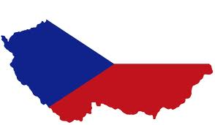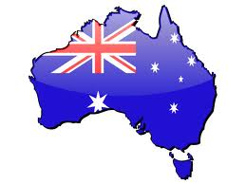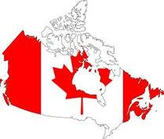

- Personal identification
- Holidays and festivals
- Travelling
- Health and illness
- Shopping and services
- Food and drinks
- Weather and seasons
- Sports and games
- Global issues
- Media and internet
- Jobs and career
- Teplice and my hometown
- The Czech Republic
- Prague
- The United Kingdom
- London
- English and American literature
- The USA
- Large American cities
- Canada
- Australia and New Zealand

POZOR! Další okruhy k ústní MZ najdete v souboru „AJ – Odborná témata“.

CAUTION! See another topics for Oral English Maturita exam in the file “Topics for the field of study“.

